*COS30018*

*Intelligent Systems*

*Task B.6*

Saynab Ismail

103063323@student.swin.edu.au

**Table of Contents**

Introduction……………………………………………………………….. 3

Part 1 ……………………………………………………....………....……3

Part 2...….….………………………………………………………..……..4

Part 3……………………………………………………………………….6

Conclusion…...….….……………………………………………….……..6

Issues……………………………………………………………………….7

References………………………………………………………………….7

Link to repository:https://github.com/SaynabIsmail/TaskB6

**Introduction**

This task aims to create a strong method for predicting stock prices by combining different models. In the first part, I utilise ARIMA to identify patterns in the stock data and LSTM, a type of deep learning model, to capture more complex trends and then combine them to create an ensemble prediction. Next, I moved on to experimenting with other models, in this case, I included Sarima to try out different settings to find the best combination. The goal is to develop a reliable approach for predicting stock prices. Finally, I attempted to include the random forest model and combine it with the rest of the models.

**Part 1**

In this section, I started by loading the stock price data and splitting it into two sets: one for training the models and one for testing their accuracy.

I first used ARIMA to model the stock price trends based on past data. ARIMA helps to capture short-term changes in stock prices by looking at patterns like trends or seasonal effects. I trained the ARIMA model on the training data and then made predictions for the test period.

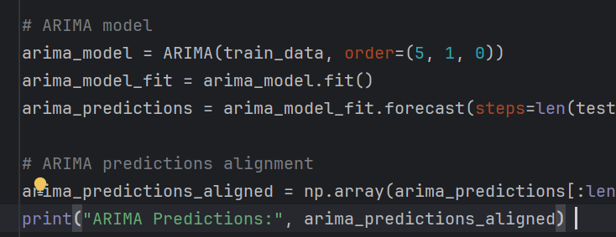

*Figure 1. ARIMA code*

For the deep learning approach, I fixed up the LSTM model and reused it from my previous assignments. LSTM is good at recognising long-term patterns in time-series data so when it's trained on scaled stock prices it can be used to predict future values.

Finally, once those two were complete I averaged the predictions from ARIMA and LSTM to create an ensemble model. By combining these models, the aim is to increase the overall accuracy of the predictions.

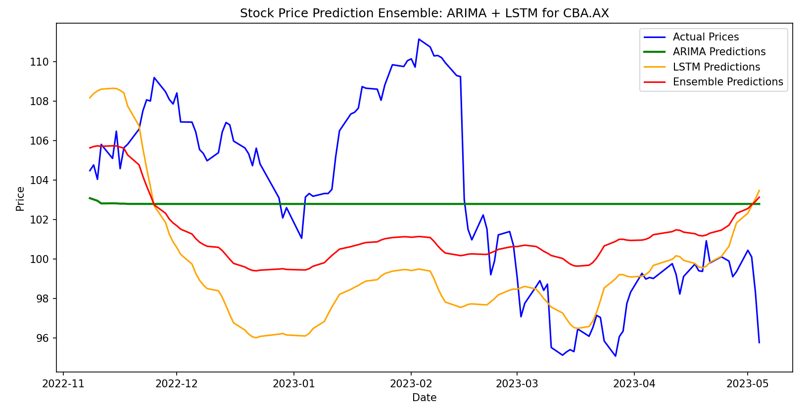

*Figure 2. Combined ARIMA + LSTM ensemble graph*

**Part 2**

In this section, I experimented with different ensemble models and configurations to improve the stock price predictions.

I first began by including the SARIMA Model. This model is similar to ARIMA and the code is almost the same however this model is better suited for data with clear seasonal trends.

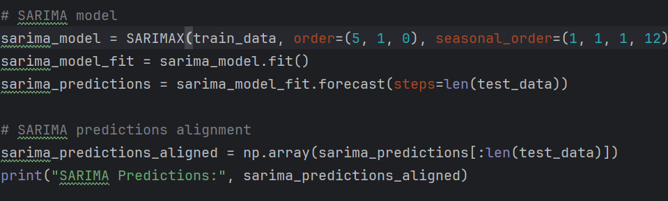

*Figure 3. SARIMA code*

After training SARIMA on the same data, we predicted future stock prices.

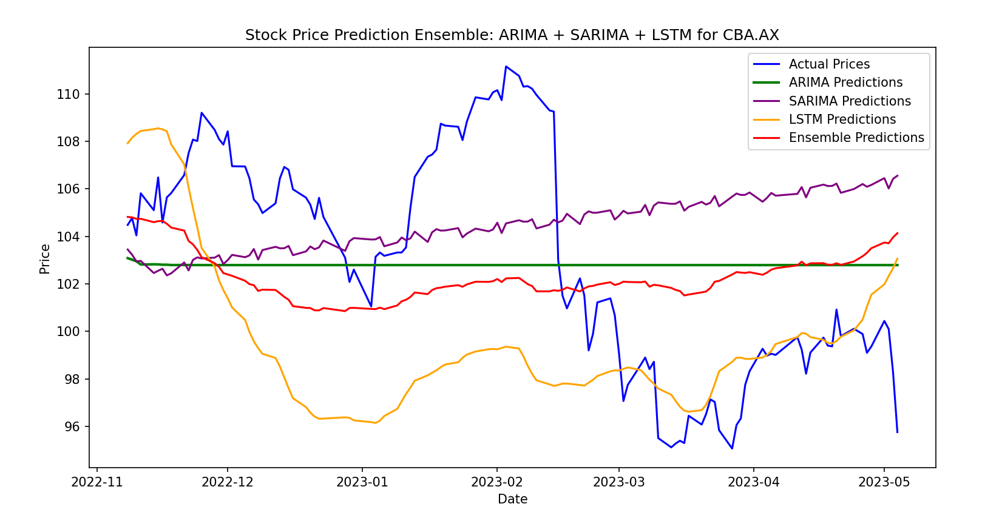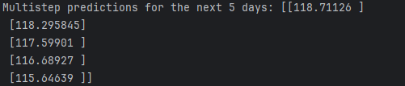

*Figure 4. Combined ARIMA + SARIMA+ LSTM ensemble graph*

**Part 3**

Finally, I wanted to add in one more additional model, the random forest model, which is a machine learning algorithm that can capture complex patterns. The idea was to see how these combinations would perform when predicting stock prices. This I don’t think worked the way I wanted it to however I decided to leave it in.

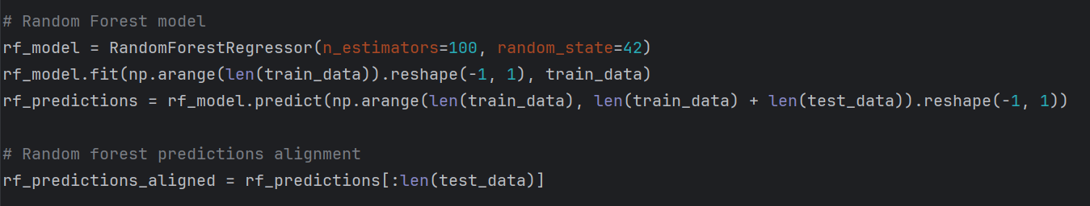

*Figure 5.Random Forest code*

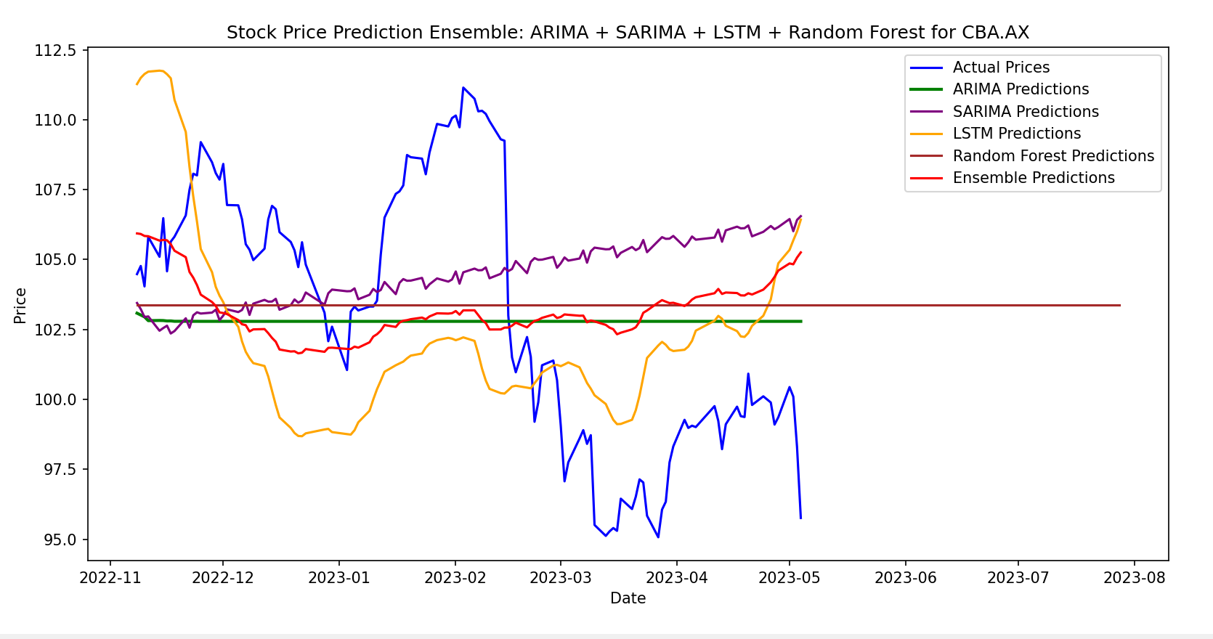

*Figure 6. Combined ARIMA + SARIMA+ LSTM + Random Forest ensemble graph*

**Conclusion**

To conclude, I created and tested different models to predict stock prices. First, I used models like ARIMA, SARIMA, and LSTM on their own, then I combined them to see if this would improve accuracy. Then I added in the Random Forest model to try and capture more complex models.

**Issues:**

Random Forest is not fully working as expected

**References:**

<https://medium.com/@tirthamutha/time-series-forecasting-using-sarima-in-python-8b75cd3366f2>